## Introduction

This exercise requires you to know the following aspects of SQL:

|  |  |
| --- | --- |
| CREATE TABLE | Concatenation |
| SQL Data Types | Formatting dates and numbers |
| INSERT INTO | Column aliases |
| SELECT | Simple JOIN statements |
| WHERE clause | Complex JOIN statements |
| LIKE and wildcards | Subquery |

## Exercise 1 – Northwind Queries (40 marks: 5 for each question)

* 1. Write a query that lists all Customers in either Paris or London. Include Customer ID, Company Name and all address fields.

Get company’s in either Paris or London

SELECT CustomerID, CompanyName, Address,city FROM Customers WHERE City = 'Paris' OR City = 'london';

* 1. List all products stored in bottles.

Find any values that have "bottles" in any position in quantityperunit column

SELECT * FROM Products WHERE QuantityPerUnit LIKE '%bottles%';

* 1. Repeat question above, but add in the Supplier Name and Country.

Join product table using supplier id FK to get company name

SELECT s.CompanyName,s.Country, * FROM Products p JOIN

Suppliers s on p.SupplierID = s.SupplierID

WHERE QuantityPerUnit LIKE '%bottles%';

* 1. Write an SQL Statement that shows how many products there are in each category. Include Category Name in result set and list the highest number first.

Inner join use because product and category the common thing between them is products contains FK for category id

SELECT c.CategoryName, COUNT(p.CategoryID) AS 'total of each product in category'

FROM Products p INNER JOIN Categories c ON p.CategoryID =c.CategoryID

GROUP BY c.CategoryName

ORDER BY 2 DESC;

“2 DESC” this is saying to order in descendent using 2nd field in the SELECT

* 1. List all UK employees using concatenation to join their title of courtesy, first name and last name together. Also include their city of residence.

The CONCAT() function adds two or more strings together so in this case I need 3 columns.

SELECT concat(TitleOfCourtesy,' ',FirstName,' ',LastName) AS 'Full Name', Address,City FROM Employees;

* 1. List Sales Totals for all Sales Regions (via the Territories table using 4 joins) with a Sales Total greater than 1,000,000. Use rounding or FORMAT to present the numbers.
  2. Count how many Orders have a Freight amount greater than 100.00 and either USA or UK as Ship Country.

Use count function to count order in USA or UK. The IN operator allows you to specify multiple values in a WHERE clause.The IN operator is a shorthand for multiple OR conditions.

SELECT COUNT(*) AS 'Number of orders' FROM Orders WHERE Freight > 100.00

AND ShipCountry IN ('USA','UK');

* 1. Write an SQL Statement to identify the Order Number of the Order with the highest amount of discount applied to that order.

“2 DESC” this is saying to order in descendent using 2nd field in the SELECT. Using MAX function to find The the largest value of the selected column which is discount.

SELECT O.OrderID,MAX(od.Discount) AS 'Highest discount applied' FROM [Order Details] od

INNER JOIN Orders O On od.OrderID = o.OrderID GROUP BY O.OrderID ORDER BY 2 DESC;

## Exercise 2 – Create Spartans Table (20 marks – 10 each)

2.1 Write the correct SQL statement to create the following table:

Spartans Table – include details about all the - on this course. Separate Title, First Name and Last Name into separate columns, and include University attended, course taken and mark achieved. Add any other columns you feel would be appropriate.

CREATE DATABASE Spartans;

CREATE TABLE students

(studentId int IDENTITY(1,1) PRIMARY KEY ,

FirstName varchar(255),

LastName varchar(255),

CourseStudied varchar(255),

University varchar (255),

grade varchar(255),

email varchar(255)

);

IMPORTANT NOTE: For data protection reasons do NOT include date of birth in this exercise.

2.2 Write SQL statements to add the details of the Spartans in your course to the table you have created.

Insert data in the order of the column I created in 2.1. stduentID is auto increment

INSERT students (FirstName, LastName, CourseStudied, University,grade,email)

VALUES ('Petra', 'Silva', 'Biomedical science', 'Brunel', '1st', 'silva@gmail.com')

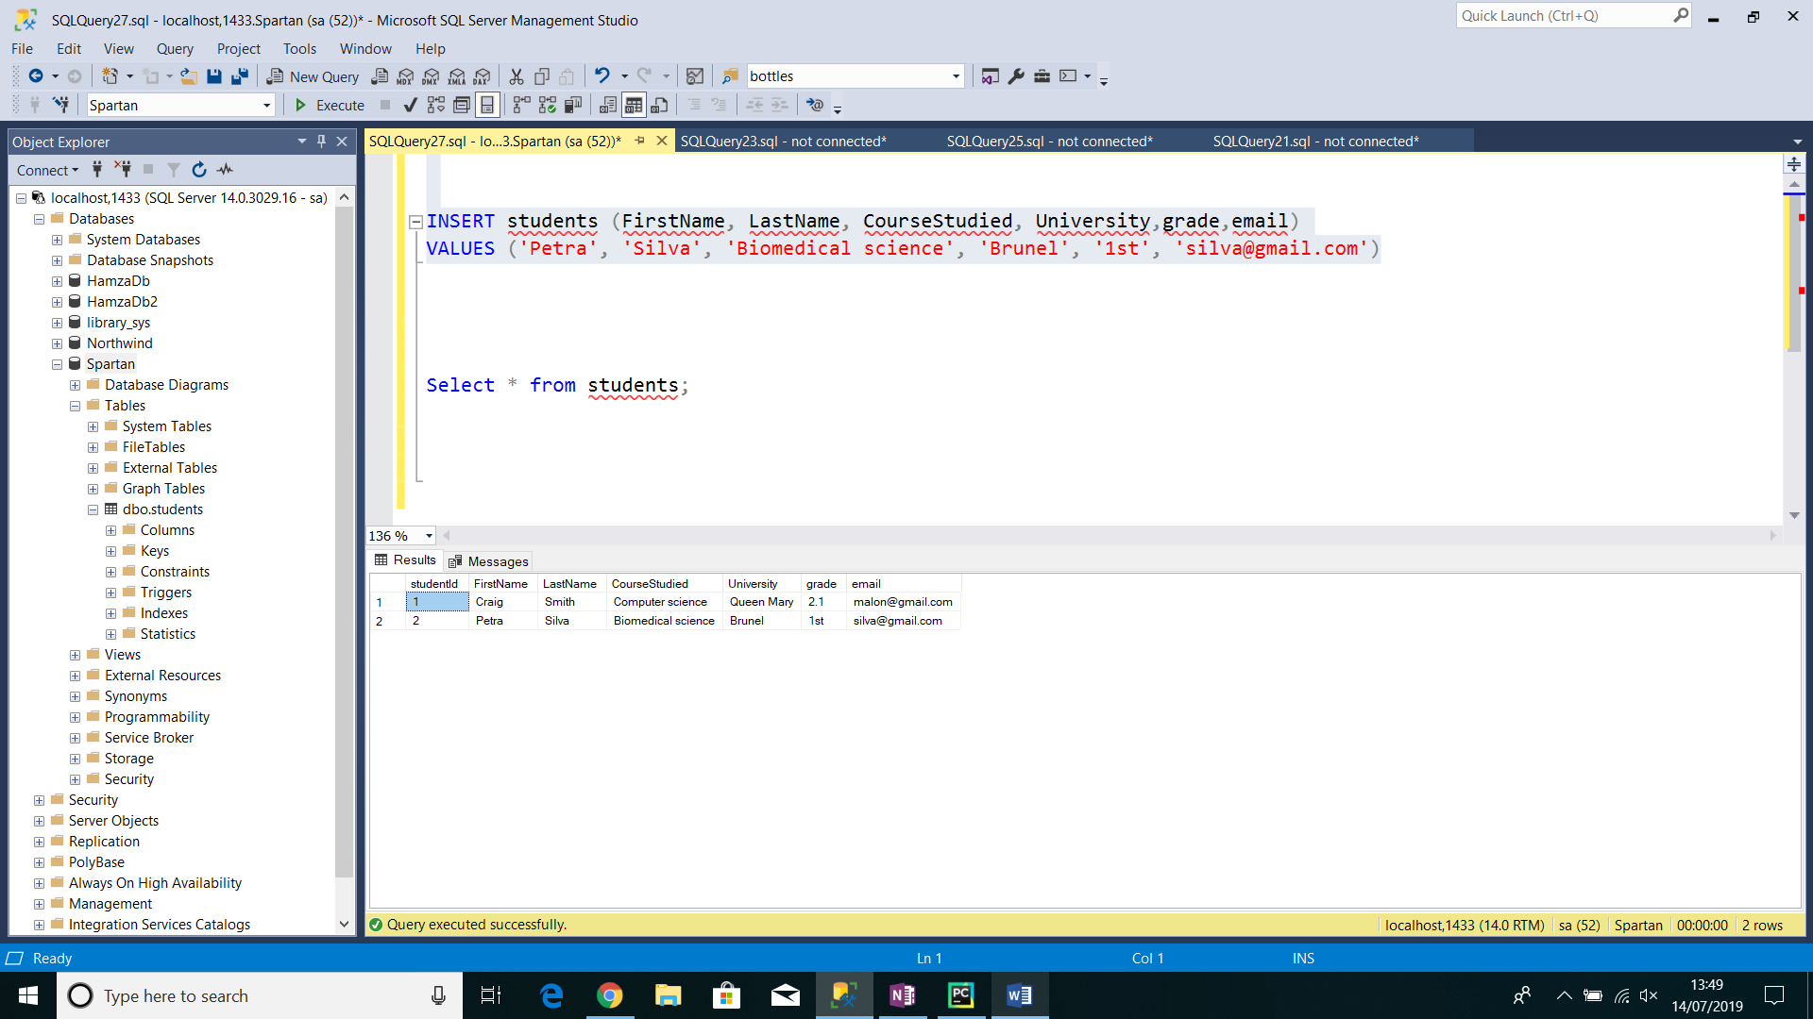

## Exercise 3 – Northwind Data Analysis linked to Excel (30 marks)

Write SQL statements to extract the data required for the following charts (create these in Excel):

3.1 List all Employees from the Employees table and who they report to. No Excel required. (5 Marks)

SELECT EmployeeID,TitleOfCourtesy, FirstName,LastName, ReportsTo, Title AS 'Report to'

FROM Employees

3.2 List all Suppliers with total sales over $10,000 in the Order Details table. Include the Company Name from the Suppliers Table and present as a bar chart as below: (5 Marks)

1st subquery is basically joining products, order details and supplier. Supplier to product and order detail to product (fk). Now filter it down to just get total sale by Quantity*od.UnitPrice > 100,000

use Northwind

SELECT

companyname,

TOTALSALES

FROM (

SELECT

s.CompanyName,

sum(od.Quantity*od.UnitPrice) AS TOTALSALES

FROM Suppliers s

INNER JOIN Products p

ON P.ProductID = s.SupplierID

INNER JOIN [Order Details] od

ON p.ProductID = od.ProductID

GROUP by s.CompanyName) sub

WHERE TOTALSALES > 10000

ORDER BY TOTALSALES ASC;

3.3 List the Top 10 Customers YTD for the latest year in the Orders file. Based on total value of orders shipped. No Excel required. (10 Marks)

3.4 Plot the Average Ship Time by month for all data in the Orders Table using a line chart as below. (10 Marks)

## Standards (10 marks)

Remember to apply all the following standards:

* Use consistent capitalisation and indentation of SQL Statements
* Use concise and consistent table alias names
* Use column aliases to ensure tidy column headings (spaces and consistent capitalisation)
* Concatenate any closely related columns e.g. First Name and Last Name or Address and City etc
* Put comments throughout